 

# A Minor Project Report on

**SMART SHOPPING CART WITH AUTOMATED**

**BILLING SYSTEM**



# ABINAYA P (20BEE4001)

**KARTHIKA P (20BEE4027)**

# MADHUMITHA D S (20BEE4044)

## DEPARTMENT OF ELECTRICAL AND ELECTRONICS ENGINEERING

**M.KUMARASAMY COLLEGE OF ENGINEERING**

## (An Autonomous Institution - Affiliated to Anna University, Chennai)

**Karur - 639113**

## April 2023

**M.KUMARASAMY COLLEGE OF ENGINEERING**

(Autonomous Institution affiliated to Anna University, Chennai)

**BONAFIDE CERTIFICATE**

Certified that this report titled “**SMART SHOPPING CART WITH AUTOMATED BILLING SYSTEM**” is the bonafide work of **ABINAYA P (20BEE4001), KARTHIKA P (20BEE4027), MADHUMITHA D S (20BEE4044)**, who carried out the work during the academic year (2022-2023).

|  |  |
| --- | --- |
| **SUPERVISOR**  Mr M Ramesh M.E.,  Assistant Professor,  Department of Electrical and Electronics  Engineering,  M Kumarasamy College of Engineering,  Karur-639113 | **HEAD OF THE DEPARTMENT**  Dr J Uma M.E., Ph.D.,  Professor & Head,  Department of Electrical and Electronics Engineering,  M Kumarasamy College of Engineering,  Karur-639113 |

Submitted for Minor Project IV (18EEP302L) viva-voce Examination held on __________

ii

## DECLARATION

We affirm that the Minor Project report titled “**SMART SHOPPING CART WITH AUTOMATED BILLING SYSTEM**” being submitted in partial fulfillment for the award of Bachelor of Engineering in Electrical and Electronics Engineering, is the original work carried out by us.

|  |  |  |
| --- | --- | --- |
| **REG.NO** | **STUDENT NAME** | **SIGNATURE** |
| **20BEE4001** | **ABINAYA P** |  |
| **20BEE4027** | **KARTHIKA P** |  |
| **20BEE4044** | **MADHUMITHA D S** |  |

## VISION AND MISSION OF THE INSTITUTION

**VISION**

* To emerge as a leader among the top institutions in the field of technical education.

## MISSION

* Produce smart technocrats with empirical knowledge who can surmount the global Challenges.
* Create a diverse, fully-engaged, learner - centric campus environment to provide Quality education to the students.
* Maintain mutually beneficial partnerships with our alumni, industry and Professional associations.

**DEPARTMENT OF ELECTRICAL AND ELECTRONICS ENGINEERING**

**VISION**

To produce smart and dynamic professionals with profound theoretical and practical knowledge comparable with the best in the field.

## MISSION

* Produce hi-tech professionals in the field of Electrical and Electronics Engineering by inculcating core knowledge.
* Produce highly competent professionals with thrust on research.
* Provide personalized training to the students for enriching their skills.

## PROGRAMME EDUCATIONAL OBJECTIVES(PEOs)

PEO1**:** Graduates will have flourishing career in the core areas of Electrical Engineering and allied disciplines.

PEO2: Graduates will pursue higher studies and succeed in academic/research careers.

PEO3**:** Graduates will be a successful entrepreneur in creating jobs related to Electrical and Electronics Engineering /allied disciplines.

PEO4: Graduates will practice ethics and have habit of continuous learning for their success in the chosen career.

## PROGRAMME OUTCOMES(POs)

After the successful completion of the B.E. Electrical and Electronics Engineering degree program, the students will be able to:

**PO1: Engineering Knowledge:** Apply the knowledge of mathematics, science, engineering fundamentals, and an engineering specialization to the solution of complex engineering problems.

**PO2: Problem Analysis:** Identify, formulate, review research literature, and analyze complex engineering problems reaching substantiated conclusions using first principles of mathematics, natural sciences, and engineering sciences.

**PO3: Design/Development of solutions:**

Design solutions for Complex engineering problems and design system components or processes that meet the specified needs with appropriate consideration for the public health and safety, and the cultural, societal and environmental considerations.

**PO4: Conduct Investigations of complex problems:** Use research-based knowledge and research methods including design of experiments, analysis and interpretation of data, and synthesis of the information to provide valid conclusions.

**PO5: Modern Tool Usage:** Create, select, and apply appropriate techniques, resources, and modern engineering and IT tools including prediction and modeling to complex engineering activities with an understanding of the limitations.

**PO6: The Engineer and Society:** Apply reasoning in formed by the contextual knowledge to assess societal, health, safety, legal and cultural issues and the consequent responsibilities relevant to the professional engineering practice.

**PO7: Environment and Sustainability:** Understand the impact of the professional engineering solutions in societal and environmental contexts, and demonstrate the knowledge of, and need for sustainable development.

**PO8: Ethics:** Apply ethical principles and commit to professional ethics and responsibilities and norms of the engineering practice.

**PO9: Individual and Team work:** Function effectively as an individual, and as a member or leader in diverse teams, and in multi-disciplinary settings.

**PO10: Communication:** Communicate effectively on complex engineering activities with the engineering community and with society at large, such as, being able to comprehend and write effective reports and design documentation, make effective presentations, and give and receive clear instructions.

**PO11: Project Management and Finance:** Demonstrate knowledge and understanding of the engineering and management principles and apply these to one’s own work, as a member and leader in a team, to manage projects and in multi-disciplinary environments.

**PO12: Life-long learning:** Recognize the need for, and have the preparation and ability to engage in independent and life-long learning in the broadest context of technological change.

**PROGRAM SPECIFIC OUTCOMES(PSOs)**

The following are the Program Specific Outcomes of Engineering Students:

**PSO1:** Apply the basic concepts of mathematics and science to analyse and design circuits, controls, Electrical machines and drives to solve complex problems.

**PSO2:** Apply relevant models, resources and emerging tools and techniques to provide solutions to power and energy related issues & challenges.

**PSO3:** Design, Develop and implement methods and concepts to facilitate solutions for electrical and electronics engineering related real-world problems.

|  |  |
| --- | --- |
| **Abstract (Key Words)** | **Mapping of POs and PSOs** |
| Radio Frequency Identification Technology Liquid Crystal Display, Arduino  Smart Shopping Cart**,** Automatic Billing  System, EM 18 RFID Reader | PO1, PO2, PO3, PO5, PO6, PO9, PO11, PSO1, PSO2, PSO3 |

## ACKNOWLEDGEMENT

Our sincere thanks to **Thiru.M.Kumarasamy,** Chairman and **Dr.K.Ramakrishnan, M.E., Ph.D., Secretary of M.Kumarasamy College of Engineering** for providing extraordinary infrastructure, which helped us to complete the Minor project in time.

It is a great privilege for us to express our gratitude to our esteemed Principal **Dr.B.S.Murugan M.Tech., Ph.D.,** for providing us right ambiance for carrying out the project work.

We would like to thank our **Head of the Department Dr.J.Uma, M.E., Ph.D., Department of Electrical and Electronics Engineering**, for her unwavering moral support throughout the evolution of the project.

We offer our wholehearted thanks to our Minor project coordinator **Dr.Sathish Kumar M.E., Ph.D., Associate Professor**, **Department of Electrical and Electronics Engineering,** for his constant encouragement, kind co-operation and valuable suggestions for making our project a success.

We would like to express my deep gratitude to our Minor Project Guide **Mr.M.Ramesh M.E., Assistant Professor**, **Department of Electrical and Electronics Engineering** for his constant encouragement, kind co-operation, valuable suggestions and support rendered in making our project a success.

We glad to thank all the **Faculty Members of Department of Electrical and Electronics Engineering** for extending a warm helping hand and valuable suggestions throughout the project.

Words are boundless to thank Our Parents and Friends for their constant encouragement to complete this Minor project successfully.

# TABLE OF CONTENTS

|  |  |  |
| --- | --- | --- |
| **Chapter No** | **Contents** | **Page No** |
|  | **ABSTRACT** | **xiv** |
|  | **LIST OF TABLES** | **xi** |
|  | **LIST OF FIGURES** | **xii** |
|  | **LIST OF ABBREVIATIONS** | **xiii** |
| **1** | **INTRODUCTION** | **1** |
|  | 1.1 Introduction | **1** |
|  | 1.2 Necessity | **2** |
|  | 1.3 Scope of the work | **3** |
| **2** | **LITERATURE SURVEY** | **5** |
| **3** | **EXISTING SYSTEM** | **9** |
|  | 3.1 Introduction | **9** |
|  | 3.2 History of Existing System [Barcode System] | **9** |
|  | 3.3 Working of Existing System | **10** |
|  | 3.4 Problem Identified with Existing System | **10** |
|  | 3.5 Limitations of existing system | **11** |
| **4** | **PROPOSED SYSTEM** | **12** |
|  | 4.1 Introduction | **12** |
|  | 4.2 Block Diagram | **13** |
|  | 4.3 Description of various blocks | **13** |
|  | 4.4 Circuit diagram | **21** |
|  | 4.5 Hardware components | **22** |

|  |  |  |
| --- | --- | --- |
| **5** | **RESULT AND DISCUSSION** | **23** |
|  | 5.1 Hardware Implementation | **23** |
|  | 5.2 Working of the Project model | **24** |
| **6** | **CONCLUSION AND FUTURE SCOPE** | **26** |
|  | 6.1 Conclusion | **26** |
|  | 6.2 Future Scope | **26** |
|  | 6.3 Advantages | **27** |
|  | 6.4 Applications | **28** |
|  | **REFERENCES** | **30** |
|  | **LIST OF PUBLICATIONS** | **31** |

## LIST OF TABLES

|  |  |  |
| --- | --- | --- |
| **Table**  **No** | **Title** | **Page**  **No** |
| 4.1 | Hardware Components and its cost | **22** |

xi

**LIST OF FIGURES**

|  |  |  |
| --- | --- | --- |
| **Figure No** | **Figure Name** | **Page No** |
| 4.1 | Block diagram of the system | **13** |
| 4.2 | Arduino UNO | **14** |
| 4.3 | Liquid Crystal Display | **15** |
| 4.4 | RFID cards | **16** |
| 4.5 | RFID cards used in our project | **17** |
| 4.6 | Transformer | **18** |
| 4.7 | EM-18 reader module | **19** |
| 4.8  4.9 | Push button  Capacitor | **20**  **20** |
| 4.10 | Circuit diagram | **21** |
| 5.1 | Demonstration test setup | **23** |
| 5.2 | LCD Display Result | **25** |
| 5.3 | LCD Display Result (Product removed) | **25** |

xii

## LIST OF ABBREVIATIONS

|  |  |  |
| --- | --- | --- |
| **S No** | **ABBREVIATION** | **EXPANSION** |
| 1. | IC | **I**ntegrated **C**ircuit |
| 2. | LCD | **L**iquid **C**rystal **D**isplay |
| 3. | RFID | **R**adio **F**requency **Id**entification |
| 4. | DC | **D**irect **C**urrent |
| 5. | AC | **A**lternate **C**urrent |
| 6. | EEPROM | **E**lectrically **E**rasable **P**rogrammable ,  **R**ead**-O**nly **M**emory |
| 7. | PID | **P**roduct **I**dentification **D**evice |
| 8 | IBM | **I**nternational **B**usiness **M**achines |
| 9 | NAFC | **N**ational **A**ssociation of **F**ood **C**hains |

xiii

## ABSTRACT

In many industries, electronic devices such as smart card readers, barcodes, and RFID scanners are used. Supermarkets need these kinds of gadgets. Currently, every person in the mall purchases the product and placed in the trolley. Upon purchase, the person will have to stand in a queue for billing. In the billing process, an employee scans each product's barcode and bills it to the final. This process can take a lot of time and it can be even worse on holidays, special offers or weekends. To overcome this, a smart way to shop in malls has been developed. Each product has an RFID tag instead of a barcode. The smart trolley features an RFID reader, LCD module. When a person places any product on the trolley, it is scanned and the product's cost, name, and expiration date are displayed. The total cost will be added to the final check out bill.

**Keywords:** Smart Shopping Cart, RFID Technology, automatic billing system, EM 18 RFID Reader

xiv

* 1. **Introduction**

## CHAPTER 1 INTRODUCTION

Throughout the century many of the innovations and information technologies are drastically changing and so as our views and expectations. A main thing where human spend their maximum time is shopping. According to survey we can say human spend approximately 1 to 1.5 hours for shopping and most of the customers will always tend to walk out of a queue if it is long. In modern world, in every supermarket and mall have shopping trolley and baskets for customers to store the purchased products. When shopping is done customers have to proceed to checkout at the billing counter. Here this billing process is quite time consuming and have to employ more human resource at the billing section. The modern technology has increased the standard of living for the humans. A supermarket is a place where customers come to purchase their daily using products and pay for them. So there is a need to calculate how many products are sold and generate the bill for the customer. When we go to a shop for shopping, we have to seek for selecting the right product. Also, after that, it is hectic to stand in line for billing all the goods. Currently there are many supermarket chains who are attempting to reduce costs like labor costs and also time of the customers. This can be achieved by replacing the existing system where many people work to collect the amount by new self-service check-out machines. Such machines involve only a single member who can handle many different machines at a time. The system provides centralized and automated billing system that uses RFID technology. To overcome this problem, we are implementing RFID based smart trolley system to minimize the rush, save time and human efforts. Our prototype has some enhanced features which will overcome this queue issue. The smart trolley system is equipped with RFID tag, RFID reader, LCD Display, Arduino Uno. The RFID tag is attached to a product. When a person puts that product in the trolley the RFID reader automatically scans the products and the details regarding the product name, cost and total price displayed on the LCD. In this project we have worked on a solution for difficulties faced by customers in standing in a queue for billing process in a supermarket. In the last few decades technology has evolved many techniques.

This has bought a revolution in many sectors of the society. In our system the inventory management is made much easier so that there is no need of a laborer for manually scanning the items. In our proposed system each smart trolley is equipped with a RFID reader, micro controller and a LCD display. Micro controller is installed on the cart for data processing and LCD display is equipped as a user interface which will show the updated bill every time the shopper add or remove any object from the cart. When the customer is finished shopping bill is generated in the shopping cart and bill amount is paid by the customers. This smart shopping system is proposed with security under consideration. Our proposed system is easy to use and no special training is required. Thus, it has the potential to make the shopping more pleasurable, easier and efficient for the customer.

## Necessity

People buy a different product and deposit them in the trolley. After total purchase, one need to go to billing counter for the payment which is very time consuming and at times very frustrating. Thus, the need for new technology arises for avoiding such problems. So, the main objective for designing this prototype is to reduce the human efforts, eliminate the queue and also eliminate the time taken during billing. Our prototype consists of components such as RFID cards which is used for identification of the product, RFID reader which is used for scanning of product when put in the trolley and it displays in the LCD Display. Automatic billing of products by using RFID technique will be a more viable option in the future. The system based on RFID technique is efficient, compact and has promising performance. Also, RFID is better and faster than barcode reading because the later works on line of sight which is not the case for RFID technique. This will take the overall shopping experience to a different level. Different parameters such as the system parameters of smart trolley like product name, product cost and total price are displayed. It eliminates the normal scanning of products at the counter and in turn, speeds up the entire process of shopping and makes the process easier. The customer will know the total amount to be paid. Hence the customer can plan his shopping only by buying the essential commodities according to his savings. Since the entire process of billing is based on RFID, so it reduces the possibility of human error substantially. The system also has a feature to delete the scanned products by customers to further optimize the shopping experience.

The smart shopping cart application helps the retailers to manage the customers in an efficient way since the customers need not have to wait in long queues. This system thus helps in achieving a faster billing system. Through this way of shopping system, more customers can be served at the same time thus benefiting the customers and retailers as well. The proposed system does not make use of an intricate routing system. A smart shopping cart supports customers scan the products by themselves and check out directly on the cart customers on longer need to wait in line at the manually cash counter. Products that are put in a smart shopping cart are read one by one and the total bill is counted and displayed. After the final bill generates the customer pays the bill by using their Pre charged cards or by cash.

## Scope of the work

The smart shopping cart helps to satisfy the customer and to reduce the time spent on the billing process which is to complete the billing process in the trolley rather than waiting in a queue. In this system, every product in Mart will have an RFID tag, and every cart will be having RFID reader. While customer put the product in the cart, at that time the RFID reader reads that RFID tag attached to that product. This project is cost effective and can be easily installed in the existing shopping carts. Automatic billing of products by using RFID technique will be a more viable option in the future. The system based on RFID technique is efficient, compact and has promising performance. Also, RFID is better and faster than barcode reading because the later works on line of sight which is not the case for RFID technique. This will take the overall shopping experience to a different level. Different parameters such as the system parameters of smart trolley like product name, product cost and total price are displayed. Development of this project can be done in many ways, where RFID tags can be replaced by RFID stickers which are small in size, low cost. Security can be improved by counting the number of items or placing weight sensors within the cart for tallying the weight and getting all the types of product names when cart is passed through a particular aisle using camera module. Multiple RFID tags can be read using a single RFID reader for a greater number of products which are added in the cart.

It eliminates the normal scanning of products at the counter and in turn, speeds up the entire process of shopping and makes the process easier. The customer will know the total amount to be paid. Hence the customer can plan his shopping only by buying the essential commodities according to his savings. Since the entire process of billing is based on RFID, so it reduces the

possibility of human error substantially. The system also has a feature to delete the scanned products by customers to further optimize the shopping experience. The smart shopping cart application helps the retailers to manage the customers in an efficient way since the customers need not have to wait in long queues. Since the data of the purchased products are displayed in the mobile display the customers can get to know about the bill details in advance with which the customer can plan for an affordable purchase. This system thus helps in achieving a faster billing system. Through this way of shopping system, more customers can be served at the same time thus benefiting the customers and retailers as well. The proposed system does not make use of an intricate routing system. The scope of a smart shopping cart with automated billing system using RFID can be quite extensive and can involve a variety of components, including: Automated billing system: The billing system will be responsible for calculating the cost of items in real time as they are added to the cart, and will provide a final bill at the end of the shopping trip. This may involve integrating with existing point-of-sale systems or developing a custom billing solution. User interface: The system will need to provide an intuitive and user-friendly interface for customers to interact with. This may involve developing a mobile app for customers to use while shopping, or providing a screen on the shopping cart itself for displaying item information and pricing. Security: The system will need to be secure to protect customer data and prevent fraud. This may involve implementing encryption and access control measures, as well as monitoring the system for suspicious activity.

**CHAPTER 2 LITERATURE SURVEY**

**[1] Nilesh Unde, Shankar Shinde, Abhishek Thombare, Satish Suryawanshi, Harshada Mhaske “IMPLEMENTATION OF SMART SHOPPING CART USING RFID” International Journal of Innovative Research in Engineering & Management (IJIREM) ISSN: 2350-0557, Volume-2, Issue-6, November- 2015.**

Supermarket is where the customers come to buy their daily products and pay for the same. Hence there is need to calculate the number of products sold and their product price to generate the bill for the customer to be paid. Cashier’s desks are placed so as to collect the bill. Currently there are many supermarket chains who are attempting to reduce costs like labor costs and also time of the customers. This can be achieved by replacing the existing system where many people work to collect the amount by new self-service check-out machines. Such machines involve only a single member who can handle many different machines at a time. The system provides centralized and automated billing system that uses RFID and Bluetooth communication modules. Each product of shopping mall or super markets will have a RFID tag which will help to identify the product type. Each shopping cart will be designed or implemented with a Product Identification Device (PID) which contains microcontroller, LCD, an RFID reader, EEPROM, and a Bluetooth module. Information of the product that is to be purchased will be read through a RFID reader on shopping cart, in the mean while that product’s information will be stored into EEPROM which will be attached to the cart and that data will be send to Central Billing System through the Bluetooth module. When the central billing system receives the cart information and data stored in EEPROM, then the system will access the product database and calculates the total amount to be paid for that particular cart. Main aim of the project is to generate automatic billing to avoid huge crowd or large queues in shopping malls and super markets. Thus, the proposed application creates an automated central bill system for supermarkets and mall.

**[2] Prof. Kirti Mhamunkar, Himanshu Saroj, Prajakta Katkar, Akansha Tiwari, Rahul Jena “RFID BASED SMART TROLLEY” 2019 IJRTI | Volume 4, Issue 4 | ISSN: 2456-3315**

People buy a different product and deposit them in the trolley. After total purchase, one need to go to billing counter for the payment which is very time consuming and at times very frustrating. So their main objective for designing this prototype is to reduce the human efforts, eliminate the queue and also eliminate the time taken during billing. Our prototype consists of components such as RFID tags which is used for identification of the product, RFID reader which is used for scanning of product when put in the trolley and it display in the LCD Display. So at the billing counter the data is sent into the server. Throughout the century many of the innovations and information technologies are drastically changing and so as our views and expectations. A main thing where human spend maximum time is shopping. According to survey we can say human spend approximately 1 to 1.5 hours for shopping and most of the customers will always tend to walk out of a queue if it is long. In modern world, in every supermarkets and malls have shopping trolley and baskets for customers to store the purchased products. When shopping is done customers have to proceed to checkout at the billing counter. Here this billing process is quite time consuming and have to employ more human resource at the billing section. To overcome this problem, we are implementing RFID based smart trolley system to minimize the rush, save time and human efforts. Our prototype has some enhanced features which will overcome this queue issue.

**[3] Vaidhyanathan RM, Venkata Krishnan, Pradeep RajG, Hemamalini S “SMART SHOPPING CART USING RFID” International Research Journal of Engineering and Technology (IRJET) e-ISSN: 2395-0056 Volume: 08 Issue: 04 | Apr 2021 www.irjet.net p-ISSN: 2395-0072**

Buying and searching for products at shopping malls are turning into a daily activity in cities. We can see large number of people shopping at malls on holidays and weekends. The rush happens when there are special offers and discounts. People purchase completely various things and place them in trolley. After total purchase, one must visit the billing counter for billing and making payments. In the billing counter, the cashier prepares the bill victimization bar code reader that might be a time overwhelming method and leads to long queues at billing counters. This paper targeted to minimize the Queue at a billing counter in a shopping mall. The smart shopping cart does the same by displaying the total price of the product kept inside the cart. In this way, the customer can directly pay the amount either in-app or in the billing counter and leave with the commodities he/she has bought. The hardware relies on Arduino Uno, RFID Reader Module, RFID Card, and Buzzer. It eliminates the normal scanning of products at the counter and in turn, speeds up the entire process of shopping, the customer shall know the total amount to be paid. Hence the customer can plan his shopping only by buying the essential commodities according to his savings. Since the entire process of billing is based on RFID, so it reduces the possibility of human error substantially. The system also has a feature to delete the scanned products by customers to further optimize the shopping experience. The smart shopping cart application helps the retailers to manage the customers in an efficient way since the customers need not have to wait in long queues. Since the data of the purchased products are displayed in the mobile display

**[4]Mrs.K.Latha,Sandhya U, Gayathri L, Vijayarani V, Mr.Santhosh kumar S “SMART SHOPPING CART USING RFID TECHNOLOGY” © 2019 IJRAR May 2019, Volume 6, Issue 2 www.ijrar.org (E-ISSN 2348-1269, P- ISSN 2349-5138).**

## The time we spend in the shopping mall increases if we have to wait in the queue for a long time at billing counters and we don’t know details about the product we buy. The proposed system will give the customer a quick shopping experience by providing the product details on the customer’s smart phone using machine learning algorithms, and will display total bill amount on the display screen attached to the cart using RFID technology. RFID is used to identify each product details not only by its type but also knowing its location. This will make sure to the customer whether their shopping is under budget or not. The time we spend in the shopping mall increases if we have to wait in the queue for a long time at billing counters and we don’t know details about the product we buy. The proposed system will give the customer a quick shopping experience by providing the product details on the customer’s smart phone using machine learning algorithms, and will display total bill amount on the display screen attached to the cart using RFID technology. RFID is used to identify each product details not only by its type but also knowing its location. This will make sure to the customer whether their shopping is under budget or not. By association rule mining algorithms sales promotion by recommending products in online shopping websites is normally achieved. This will be the first smart cart offline retail system, that will recommend products to customers based on the products dropped in the cart by customers. In this system, the combination of frequent item set generation algorithm and automatic billing system using RFID technology will give the customers ease of automatic billing and sales promotion based on their product purchase. For implementing this system in real time, barcode system needs to be replaced by RFID system.

## Introduction

**CHAPTER 3 EXISTING SYSTEM**

Barcodes are everywhere. They’re in your kitchen cabinets, stacked on our bookshelf etc.., Barcodes have become so omnipresent that they often go unnoticed, and consumers are so familiar with them that they know how to scan them to check themselves out at the grocery store. Since their invention 70-plus years ago, barcodes have turned into an essential tool for businesses to make their inventory control and sales operations more efficient and track products as they move through the supply chain. This technology has proven critical to the success of many businesses—yet few companies think about whether they’re maximizing the humble barcode.

## History of Existing System [Barcode System]

Norman Joseph Woodland and Bernard Silver came up with the idea for barcodes based on the symbols in Morse code. The two recent graduates of Drexel Institute of Technology, now Drexel University, applied for a patent for the invention in 1949 and received it three years later. Woodland sought the help of his employer, IBM, in building this technology, but IBM felt technological limitations in force at that time would prevent barcodes from catching on. The founders sold the patent to electronics company Philco in 1962, and Philco later sold it to RCA. The railroad industry was one of the first to experiment with barcodes in the early 1960s, with a project spearheaded by David Jarrett Collins of electronics company Sylvania. To monitor the movement of railcars, Collins created a colorful barcode that was placed on the side of cars and scanned by a device next to the railroad tracks. Though this was an important first step, the system had some issues, and the Association of American Railroads gave up on it in the late ‘70s. Another early adopter was General Motors, which used barcodes to track transmissions as they moved around a factory. Barcodes didn’t gain real traction until the mid-70s, when grocery stores started testing them. Around that same time, the National Association of Food Chains (NAFC) standardized barcodes for the industry by developing an 11-digit code. In 1977, there were still only a few hundred supermarkets using barcodes, but by 1980 thousands of stores were adding them every year. Soon, barcodes were standard in not only grocery stores but most retail environments.

## Working of Existing System

The width of the black bars usually represents the numbers 0 or 1, while the sequence of those bars signifies a number between 0 and 9. A computer connected to the scanner has all the information on what item is associated with that unique combination of bars and spaces and may add, multiply or divide those numbers to identify the correct product, which shows up on the screen. In a warehouse, the barcode might encode an item’s size, color and other attributes, as well as its location, so the company has a detailed view of current inventory and can quickly fulfill orders or conduct physical inventory counts. In a retail setting, this information could include the product name and price that an associate needs to check out a customer. Organizations can use barcodes to track goods throughout their life cycle, from manufacture to distribution to purchase to service and repair.

## Problem Identified with Existing System

In the existing system, they have used the traditional method of barcode scanning. Using the barcode scanner, we need to scan each product and so this method becomes very slow to be scanned. A barcode reader is associated in electronic device for reading with the barcodes. In this process we have no automatic billing system and the customer has wait for the billing process in the long queues. Therefore, using the barcode process billing method is slow. This eventually results in the long queues. To avoid the process, we introduced types of technology is the RFID based billing system. User can pay the amount through credit/debit cards or by cash. But it is the time consumption process for the billing purpose. So, the waiting time to pay the bill is increased. To overcome, the time consumption process the RFID based smart trolley system is proposed. While the customer keeps the product in the smart trolley, the Radio frequency ID reader automatically senses the product by scanning the tag. And its corresponding electronic product code number is generated automatically. To store the item price and total billing data, microcontroller memory is used LCD display. This electronic product code provides the information of the product its name and price. At present they use the barcode method in shopping malls. In this method, every product has a barcode label on it which might be scanned with the help of specially designed barcode readers. A barcode reader is an electronic device used for reading information encoded with a barcode label.

A lens and a light sensor converting optical impulses into electrical ones are the key

components of a barcode scanner. Additionally, barcode readers contain decoder circuitry, which analyzes the barcode's data provided by the sensor and sends the barcode's content to the scanner's output port. We have a tendency to choose any product for purchasing we place it in a trolley and take it to the cashier. Then the products will be scanned by the cashier through a barcode reader one by one. After this, cashier provides the bill. But this will be tedious once a ton of products is being scanned. Therefore, this billing method will be slow. This eventually results in long queues.

## Limitations of Existing System

* + - The customers pick a basket and fetch the desired product they want to purchase and next process is billing section. The billing process in the shopping system is quite tedious and time consuming and each one waiting in queue for their turn to generate bill because each and every product whether the basket contain more or less items. Due to this reason, there is requirement of more & more human resources on such billing section.
    - Works only in short range.
    - We have to pay in general after completing our shopping.
    - We cannot see product admin.
    - It is tedious and time consuming.
    - It consumes lot of manpower to better result.
    - It lacks of data security.
    - Retrieval of data takes lot of time.
    - Reports take time to produce.

## Introduction

**CHAPTER 4 PROPOSED SYSTEM**

The customers pick a basket and fetch the desired product they want to purchase and next process is billing section. The billing process in the shopping system is quite tedious and time consuming and each one waiting in queue for their turn to generate bill because each and every product whether the basket contain more or less items. Due to this reason, there is requirement of more & more human resources on such billing section. In Today’s accelerating world, shopping at malls or supermarkets have become lifesaver for people, if time is concerned as one of the important factors. Innovation in technology is basically aimed towards making day to day life of people easier and faster. In huge cities we see big rush at malls on holidays and weekends. People buy different products and one-by-one put them in trolley. After completion of shopping of the goods, customer needs to go to billing counter for payment. There the product’s barcode tag is read and the bill is prepared. This is very time-consuming process and results in long queue at counter. This system is developed to help a person in everyday shopping in terms of reduced time spent while purchasing. The main objective of proposed system is to provide a technology oriented, low-cost, easily handled, and efficient system for facilitating shopping in person. In this project we have worked on a solution for difficulties faced by customers in standing in a queue for billing process in a supermarket. In the last few decades technology has evolved many techniques. This has bought a revolution in many sectors of the society. In our system the inventory management is made much easier so that there is no need of a laborer for manually scanning the items. In our proposed system each smart trolley is equipped with a RFID reader, micro controller and a LCD display. Micro controller is installed on the cart for data processing and LCD display is equipped as a user interface which will show the updated bill every time the shopper add or remove any object from the cart. When the customer is finished shopping bill is generated in the shopping cart and bill amount is paid by the customers. This smart shopping system is proposed with security under consideration. Our proposed system is easy to use and no special training is required. Thus, it has the potential to make the shopping more pleasurable, easier and efficient for the customer.

## Block Diagram

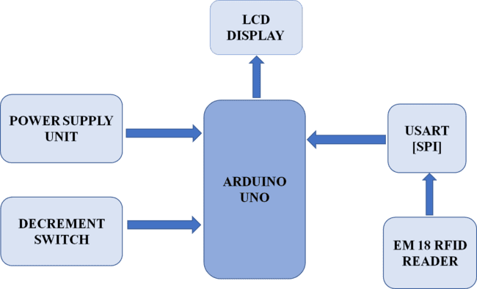

**Figure.4.1 Proposed model**

## Description of Various blocks

## Arduino UNO:

Arduino Uno is an open-source microcontroller board based on the processor ATmega328P. There are 14 digital I/O pins, 6 analog inputs, a USB connection, a power jack, an ICSP header, and a reset button. It contains all the necessary modules needed to support the microcontroller. It's intended for artists, designers, hobbyists, and anyone interested in creating interactive objects or environments. Arduino can sense the environment by receiving input from a variety of sensors and can affect its surroundings by controlling lights, motors, and other actuators.

Arduino UNO is a popular microcontroller board based on the ATmega328P microcontroller, developed by Arduino LLC. It is widely used in electronic projects and prototyping, as it is easy to use, inexpensive, and has a large online community for support and resources. The Arduino UNO board features 14 digital input/output pins, 6 analog input pins, a USB connection, a 16 MHz quartz crystal oscillator, and a power jack. It can be programmed using the Arduino Integrated Development Environment (IDE), which is based on the Processing language and is free and open-source. The Arduino UNO board can be used to control a wide range of electronic components such as LEDs, motors, sensors, and displays. It is also compatible with a variety of shields (add-on boards), which allow it to expand its functionality and connect to other devices and systems. One of the main advantages of the Arduino UNO board is its simplicity and ease of use, even for beginners in electronics and programming. Its low cost and open-source nature also make it accessible to a wide range of users, from hobbyists to professionals. Overall, the Arduino UNO board has become a popular choice for electronic projects and prototyping due to its versatility, ease of use, and strong community support.

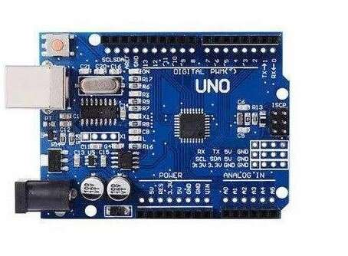

## Figure.4.2 Arduino UNO

**Liquid Crystal Display:**

The liquid crystal display (LCD) panel is designed to project on-screen information of a microcomputer onto a larger screen with the aid of a standard overhead projector, so that large audiences may view on-screen information without having to crowd around the TV monitor. LCDs are made with either a passive matrix or an active matrix display grid. A display is made up of millions of [pixels.](https://www.techtarget.com/whatis/definition/pixel) The quality of a display commonly refers to the number of pixels; for example, a 4K display is made up of 3840 x2160 or 4096x2160 pixels. It is also known as a thin film transistor ([TFT](https://www.techtarget.com/whatis/definition/thin-film-transistor-TFT)) display LCDs consume much less power than LED and gas-display displays because they work on the principle of blocking light rather than emitting. An LCD (Liquid Crystal Display) is a type of flat panel display used in a wide range of electronic devices, including televisions, computer monitors, smart phones, and digital watches. The LCD screen consists of several layers, including two polarizing filters with a layer of liquid crystal material between them. When an electrical current is applied to the liquid crystal material, it changes the orientation of the crystals and controls the amount of light passing through the polarizing filters, creating the images that we see on the screen. LCD displays are popular because they consume less power than other types of displays, making them ideal for battery- powered devices. They also have a longer lifespan and are generally more reliable than other types of displays. There are several different types of LCD displays, including TN (Twisted Nematic), IPS (In-Plane Switching), and VA (Vertical Alignment). Each type has its own advantages and disadvantages in terms of viewing angles, color accuracy, and response time. These LCD displays have become a ubiquitous part of modern technology and are used in a wide range of electronic devices due to their low power consumption, reliability, and versatility.

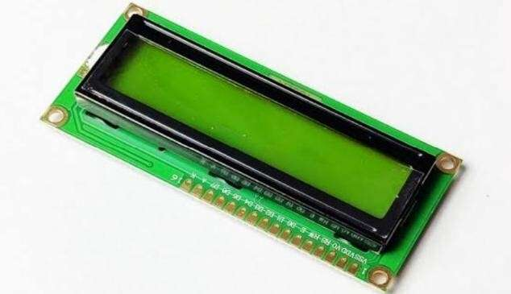

## Figure.4.3 Liquid Crystal Display

**RFID cards:**

RFID cards, or radio frequency identification cards, use radio waves to communicate with a reader, allowing the user to gain access by simply holding the card near the reader. On the other hand, mobile access uses a smartphone or other mobile device as the means of access. This card is attached to the products, scanned by the RFID reader and used for the billing purposes. RFID (Radio Frequency Identification) cards are a type of contactless smart card that use radio frequency technology to communicate with a reader. They are used for a variety of purposes such as access control, payment systems, and inventory tracking. RFID cards have a microchip and an antenna embedded in them. When the card is brought near an RFID reader, the reader sends a radio signal to the antenna, which powers up the microchip and allows it to communicate with the reader. The data stored on the chip can then be transmitted to the reader, allowing for authentication or other actions. There are two types of RFID cards: passive and active. Passive RFID cards do not have a power source of their own and rely on the energy from the reader to power the chip. Active RFID cards have their own power source and can communicate with the reader over longer distances. They are commonly used in access control systems, where they can be used to grant or deny access to certain areas or resources. They are also used in payment systems, such as contactless payment cards and mobile payment systems like Apple Pay and Google Wallet. In inventory tracking, RFID cards can be used to track the movement of goods and materials through a supply chain.

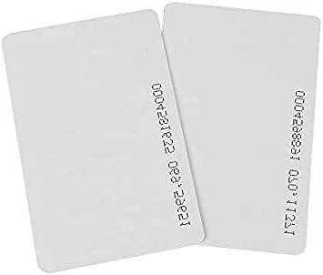

## Figure.4.4 RFID cards

In our project we have used these three RFID cards:

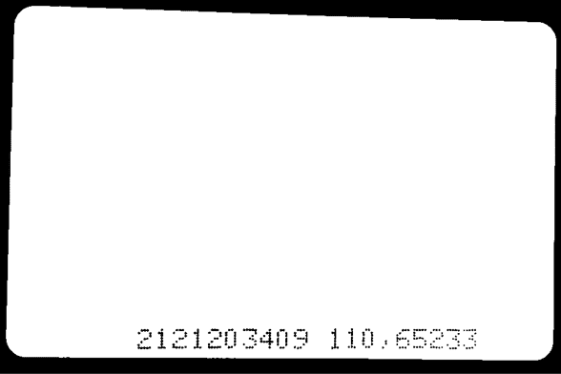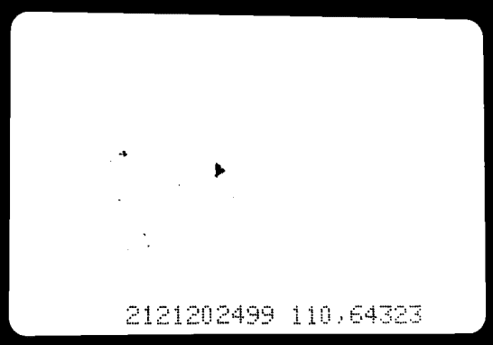

## 5 STAR Rs.20 PARLE-G Rs.15

**Transformer:**

## BUTTER Rs.30

**Figure.4.5 RFID cards used in our project**

The transformer 230V to 12V is a type of power supply device that is used to step down the voltage from 230 volts to 12 volts, which is a more suitable voltage level for the smart shopping cart with automated billing system using RFID. A transformer is a device that transfers electric energy from one alternating-current circuit to one or more other circuits, either increasing (stepping up) or reducing (stepping down) the voltage. The basic principle behind working of a transformer is the phenomenon of mutual induction between two windings linked by common magnetic flux. Here, it is used to convert 230V to 12V.

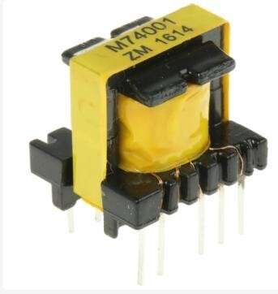

## Figure 4.6 Transformer

**EM-18 Reader Module:**

The EM-18 Reader Module is a type of RFID (Radio Frequency Identification) reader that can read 125KHz RFID tags. It is commonly used in applications such as access control systems, time and attendance systems, and asset tracking systems. It is a compact and easy-to-use device that can be easily integrated into a variety of systems. It is designed to be powered by a 5V DC power supply and communicates with the host system through a simple TTL (Transistor-Transistor Logic) interface. The EM-18 Reader Module is typically used in conjunction with RFID tags, which are small electronic devices that can be attached to or embedded in objects. When an RFID tag comes within range of the reader, it emits a signal that is picked up by the reader and used to identify the object. It is a cost-effective and reliable RFID reader that is well-suited for a variety of applications. Its compact size and simple interface make it easy to integrate into existing systems, and its ability to detect RFID tags at a distance of up to 10cm makes it suitable for use in a wide range of environments.

* **Supply Voltage** : 5V
* **Operating Frequency:** 125KHz
* **Read Distance** : 10cm
* **Current Rating** : < 50mA

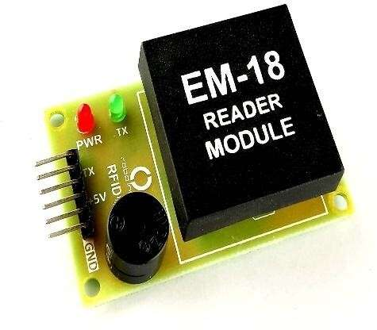

## 

## Figure 4.7 EM-18 Reader Module

**Push Button:**

Push button switches can be designed with a variety of actuator types, including round, square, and rectangular shapes. They can also have different types of contacts, such as normally open (NO) or normally closed (NC), which determine the default state of the switch when not activated. One common application of push button switches is in control panels and machinery, where they are used to activate specific functions or operations. They can also be used as emergency stop switches, which are designed to quickly shut down machinery in case of an emergency. A push button switch controls an action in a machine or other type of process. They are common features within the home and workplace, and are also referred to as pushbutton switches or push switches. A push button switch is a type of switch that is activated by pressing a button. It is a momentary switch, which means that it only stays in the ON position for as long as the button is being pressed. Once the button is released, the switch returns to its original position and turns OFF.

* These switches react to user interaction with the button or switch when it makes contact with the control panel beneath
* simply connect it to a computer with a USB cable or power it with a ac-to-dc adapter or battery to get started
* Size: 5 x 5 x 5mm it is a pack of 20 tactile switch

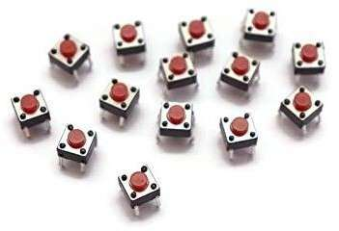

## Figure 4.8 Push Button

**Capacitor:**

A capacitor is a two-terminal electrical device that can store energy in the form of an electric charge. It consists of two electrical conductors that are separated by a distance. The space between the conductors may be filled by vacuum or with an insulating material known as a dielectric.

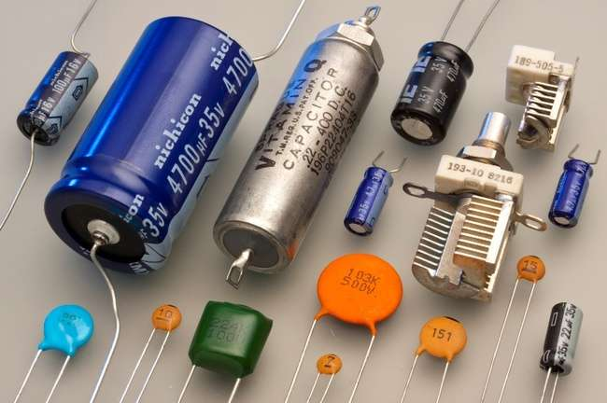

**Figure 4.9 Capacitor**

## 4.4 Circuit Diagram

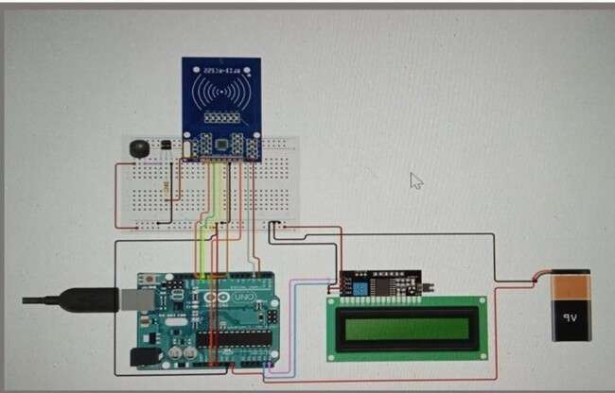

**Figure 4.10 Circuit Diagram**

* + - The power supply is given to microcontroller board (UNO) through rectifying unit and transformer which converts the incoming ac to dc and it is desirable for all components to get initialized for working.
    - From Arduino UNO, LCD Display (16x2) and the EM-18 RFID Reader Module are connected, the EM-18 Reader will be used to scan the products with RFID cards.
    - After scanning, the data will be sent to microcontroller, and then it reaches LCD Display which will display the price details and the product name.
    - This is the simple connection of our project which makes easier and simpler to implement in carts of all shopping malls and super markets.

## Hardware Components

|  |  |  |  |  |
| --- | --- | --- | --- | --- |
| **S.NO** | **COMPONENTS** | **SPECIFICATION** | **QUANTITY** | **COST**  **in Rs.** |
| 1 | Arduino | UNO | 1 | 800 |
| 2 | Liquid Crystal Display | 16X2 LCD 12V | 1 | 250 |
| 3 | RFID cards | Plastic thin card | 3 | 450 |
| 4 | Transformer with full bridge  Rectifier | 230V to 12V | 1 | 580 |
| 5 | EM-18 reader module | EM-18 | 1 | 450 |
| 6 | Push button | MAX 50mA24DC | 1 | 80 |
| **Total = 2295** | | | | |

**Table 4.1 Hardware Components**

## CHAPTER 5 RESULT AND DISCUSSION

* 1. **Hardware Implementation**

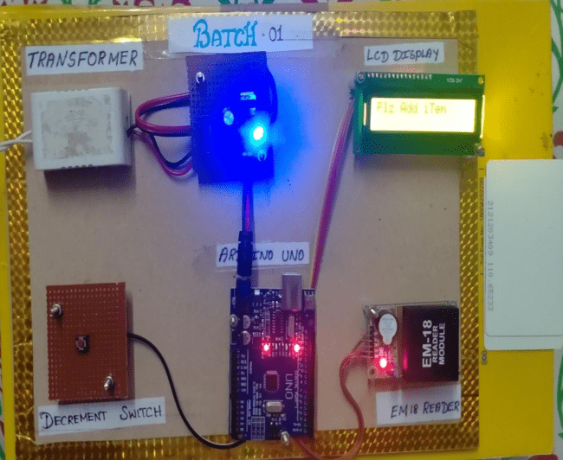

**Figure 5.1 Demonstration test setup of smart shopping cart with automated billing system**

**5.2 Working of the project**

* Arduino is interfaced with all the remaining components. Once the microcontroller is powered up with the use of a 9V battery it is initialized and set to the basic settings, now the system is ready to proceed which means the RFID card and the tag can be scanned.
* Then the RFID card or tag is scanned the RFID reader fetches all the details from the scanned card or tag, and if the scanning process is successful the product details will be transferred to the microcontroller memory and then will be transferred to the LCD module to be displayed on the LCD screen.
* Here the RFID module uses the SPI communication technique to transfer or to retrieve the data from the RFID card or tag.
* To add a product, we shall scan the respective product tag. Once the tag is scanned, the product price details and the total price will be displayed in the LCD screen.
* To remove a added product, we shall press the decrement switch and scan the product tag need to be removed. The product will be removed and the total price will be displayed in the LCD screen.
* The entire process is repeated until the shopping process gets complete. After the shopping is completed the entire bill details will be displayed on the LCD screen, each card or tagacts as a product, where the product details are pre early set or dumped into the card.
* A smart shopping cart supports customers scan items by themselves and check out directly on the cart customers on longer need to wait in line at the manually cash counter.
* Items that are put in a smart shopping cart are read one by one and the bill is generated and displayed. After the final bill generates the customer pays the bill by using their Pre charged cards provided by the shopping mall.
* The entire working process is implemented by the software called Arduino IDE. The Proteus simulation software is used to check the simulation results before the hardware implementations.
* The customer can pay using a variety of methods such as credit card, cash, or mobile payment.
* The automated billing system also helps to reduce errors and speed up the checkout process, as the need for manual scanning of each item and manual entry of the price is eliminated.

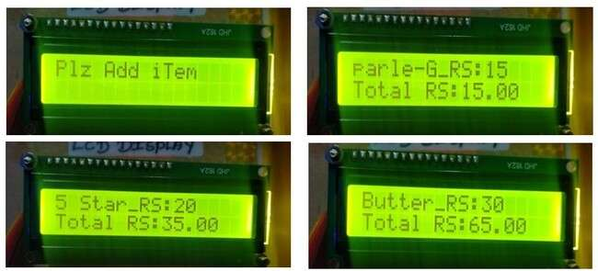

**Figure 5.2 LCD Display Result**

**The figures shown above represent the output of our project;**

The first image shows the “Plz add item”, it will be displayed until we add any items or products in the cart.Once we started to scan our products, it will display the product name, its price and the total price.From image 2, 3 and 4, we can infer that Parle-G, 5 star and Butter are scanned respectively, then their prices are added.Finally, it displays the total price to be paid by the customers. So, the customer will know the total amount to be paid.

**Decrement process:**

The system also has a feature to delete the scanned products by customers to further optimize the shopping experience.When we want to remove the product which was mistakenly taken by the consumer, press the decrement push button and scan the mistaken product simultaneously, then the product’s price will be decremented in the total price.

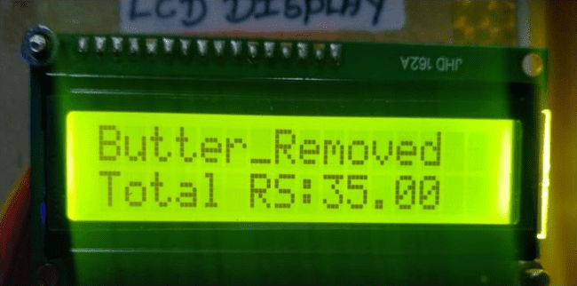

## Figure 5.3 LCD Display Result (Product removed)

## 6.1 Conclusion

**CHAPTER 6**

**CONCLUSION AND FUTURE SCOPE**

Smart shopping carts with automated billing systems using RFID technology have the potential to revolutionize the retail industry by improving the shopping experience for customers and increasing efficiency for retailers. A smart shopping cart supports the customers to scan their products by themselves and check out directly on the cart customers on longer need to wait in line at the manually cash counter. RFID technology allows for quick and efficient scanning of products, reducing the need for manual input and making the shopping experience more convenient for customers. It also eliminates the need for manual scanning and billing, reducing the workloads on store employees and minimizing errors in billing. This not only saves time but also enhances the overall shopping experience. As technology continues to advance, we can expect to see more widespread adoption of these systems in the retail industry.

**6.2 Future scope**

Development of this project can be done in many ways, where RFID tags can be replaced by RFID stickers which are small in size, low cost. Security can be improved by counting the number of items or placing weight sensors within the cart for tallying the weight and getting all the types of product names when cart is passed through a particular aisle using camera module. Multiple RFID tags can be read using a single RFID reader for more number of products which are added in the cart. The future scopes of smart shopping carts with automated billing systems using RFID technology are vast and promising.

## 

Here are some of the potential areas where this technology could make a significant impact:

* **Enhanced customer experience**: Smart shopping carts with automated billing systems using RFID technology can significantly improve the shopping experience for customers. These systems can offer personalized recommendations, suggest complementary products, and help customers locate items within the store. They can also provide information on product availability and pricing in real-time, allowing customers to make informed decisions.
* **Increased efficiency**: Smart shopping carts can reduce the time spent waiting in checkout lines by automatically scanning and billing products. This can also reduce the workload on store employees, allowing them to focus on other tasks such as customer service and inventory management.
* **Improved inventory management**: RFID technology can help retailers keep track of inventory in real-time, reducing stock-outs and overstocking. Smart shopping carts can also help retailers identify which products are popular and which ones are not, allowing them to optimize their inventory accordingly.
* **Reduced waste**: Smart shopping carts can help reduce waste by allowing retailers to track expiration dates and ensure that products are sold before they expire. This can help reduce food waste and other types of waste in the retail industry.
* **Data analytics**: Smart shopping carts with automated billing systems using RFID technology can generate vast amounts of data on customer behavior, preferences, and shopping patterns. This data can be used to improve inventory management, optimize store layouts, and develop personalized marketing strategies.

## 6.3 Advantages

There are several advantages to using smart shopping carts with automated billing systems using RFID technology in the retail industry:

**Faster checkout process**: Smart shopping carts with automated billing systems using RFID technology can significantly reduce the checkout time, as products are automatically scanned and billed as they are added to the cart.

**Improved accuracy**: RFID technology reduces the risk of billing errors that may occur due to manual scanning, making the billing process more accurate.

**Enhanced customer experience**: Smart shopping carts can offer a more personalized shopping experience by providing product recommendations, promotions, and deals based on the customer's purchase history.

**Real-time inventory management**: RFID technology allows retailers to track inventory in real- time, making it easier to restock and manage inventory levels.

**Increased efficiency**: Smart shopping carts with automated billing systems using RFID technology reduce the workload on store employees, allowing them to focus on other tasks such as customer service and inventory management.

**Improved data analytics**: The use of RFID technology can generate data on customer behavior, preferences, and shopping patterns, which can be analyzed to improve inventory management, optimize store layouts, and develop personalized marketing strategies.

**Cost-effective**: Although the initial investment required for implementing RFID technology may be high, it can be cost-effective in the long run due to the reduction in checkout time, improved accuracy, and increased efficiency.

## 6.4 Applications

Smart shopping carts with automated billing systems using RFID technology have several applications in the retail industry. Here are some of the most prominent applications:

**Grocery stores**: Smart shopping carts can be used in grocery stores to provide a more convenient shopping experience. Customers can easily add products to their carts, and the automated billing system ensures that they are charged accurately and quickly.

**Supermarkets**: Smart shopping carts with RFID technology can be used in supermarkets to improve the shopping experience for customers. They can also help retailers optimize their inventory by tracking product popularity and restocking items in real-time.

**Retail stores**: Smart shopping carts with automated billing systems using RFID technology can be used in retail stores to improve the checkout process and reduce the workload on store employees. This can allow them to focus on other tasks such as customer service and inventory management.

**Shopping malls**: Smart shopping carts can be used in shopping malls to provide a more personalized shopping experience for customers. The carts can offer product recommendations and promotions based on the customer's purchase history, making it easier for them to find what they need.

**Libraries:** RFID-enabled shopping carts can be used in libraries to automate the checkout process. Customers can use the cart to scan the RFID tags on the books they want to borrow, and the system will automatically check them out and charge any applicable fees.

**Airports:** Smart shopping carts can be used in airports to make it easier for travelers to purchase last-minute items before boarding their flights. Automated billing systems can be integrated with the airport's security system to ensure that only authorized passengers are able to use the carts.

**Museums:** RFID-enabled shopping carts can be used in museums to provide visitors with a more interactive experience. For example, visitors can use the cart to scan QR codes on exhibits to learn more about them, and they can purchase souvenirs using the cart's automated billing system. Smart shopping carts with automated billing systems using RFID technology have several potential applications in the retail industry, including: Inventory management: RFID technology can help retailers track inventory levels and quickly restock items that are running low. This can help reduce out-of-stock situations and ensure that popular items are always available for customers. Personalized promotions: Smart shopping carts can be integrated with customer loyalty programs and offer personalized promotions and discounts based on a customer's shopping history. Reduced shrinkage: RFID technology can help reduce shrinkage by providing real-time information on the location of products, making it easier to identify and prevent theft.

Overall, smart shopping carts with automated billing systems using RFID technology have the potential to revolutionize the retail industry by providing a more convenient, efficient, and personalized shopping experience for customers, while also improving operational efficiency and reducing costs for retailers.

## REFERENCES

* + 1. A.Sarac,N.Absi, S.Dauzere-Peres, “A Literature Review of impact of RFID technologies in Supply Chain Management”, France, March 2009.
    2. https:/[/www.ij](http://www.ijert.org/smart-shopping-cart-with-automated-billing-system)e[rt.org/smart-shopping-cart-with-automated-billing-system](http://www.ijert.org/smart-shopping-cart-with-automated-billing-system)
    3. J. Wan, Z. Shu, D. Li, S. Wang, M. Imran, A. Vasilakos and S. Tang, “Software-defined Industrial Internet of Things in the context of Industry 4.0”, IEEE Sensors Journal, vol. 16, no. 20, pp. 7373-7380.
    4. Mr.P. Chandrasekar,Ms.T. Sangeetha,"Smart Shopping Cart with Automatic Billing System through RFID and ZigBee" in IEEE S.A.Engineering College, Chennai, Tamil Nadu, 2014,India.
    5. Ankit Anil Agarwal, Saurabh Kumar Sultania, Gourav Jaiswal, Prateek Jain, “RFID Based Automatic Shopping Cart”, Control Theory and Informatics Vol 1, No.1, 2011.3
    6. Dr. Suryaprasad J, Praveen Kumar B O, Roopa D & Arjun A K "A Novel Low-Cost Intelligent Shopping Cart", 2014 IEEE.
    7. P. Shah, J. Jha, N. Khetra, and M. Zala, “A literature review on improving error accuracy and range based on RFID for smart shopping”, IJSRD - International Journal for Scientific Research & Development, Vol. 3, Issue 10, 2015, ISSN (online): 2321- 0613.
    8. H. H. Bi and D. K. Lin "RFID-enabled discovery of supply networks", IEEE Trans. Eng. Manag., vol. 56, no. 1, pp.129 - 141 2009
    9. Pritha N, Sahana S, Selvin Stephy, Shiny Rose, Unnamalai, Smart Trolley System for Automated Billing using RFID and IoT (2018), Panimalar Engineering College, Tamil Nadu, India.
    10. Pavni Swaroop, AkshitaParasari, Mansi Singh, Shobha Rajput, 2020. A Review paper on Smart Trolley System for Automated Billing using RFID and IoT.

1. [4] J. D. Porter and D. S. Kim "An RFID-enabled road pricing system for
2. transportation", IEEE Syst. J., vol. 2, no. 2, pp.248 -257 2008
3. [5] H. H. Bi and D. K. Lin "RFID-enabled discovery of supply networks",
4. IEEE Trans. Eng. Manag., vol. 56, no. 1, pp.129 -141 2009
5. [6] K. Finkenzeller RFID Handbook: Fundamentals and Applications in
6. Contactless Smart Cards and Identification, 2003 :Wiley
7. [7] J. Z. Gao , L. Prakash and R. Jagatesan "Understanding 2D-BarCode
8. technology and application in M-commerce-design and implementation
9. of a 2D barcode processing solution", Proc. Comput. Softw. Appl.
10. Conf., pp.49 -56 2007
11. [4] J. D. Porter and D. S. Kim "An RFID-enabled road pricing system for
12. transportation", IEEE Syst. J., vol. 2, no. 2, pp.248 -257 2008
13. [5] H. H. Bi and D. K. Lin "RFID-enabled discovery of supply networks",
14. IEEE Trans. Eng. Manag., vol. 56, no. 1, pp.129 -141 2009
15. [6] K. Finkenzeller RFID Handbook: Fundamentals and Applications in
16. Contactless Smart Cards and Identification, 2003 :Wiley
17. [7] J. Z. Gao , L. Prakash and R. Jagatesan "Understanding 2D-BarCode
18. technology and application in M-commerce-design and implementation
19. of a 2D barcode processing solution", Proc. Comput. Softw. Appl.
20. Conf., pp.49 -56 2007
21. [4] J. D. Porter and D. S. Kim "An RFID-enabled road pricing system for
22. transportation", IEEE Syst. J., vol. 2, no. 2, pp.248 -257 2008
23. [5] H. H. Bi and D. K. Lin "RFID-enabled discovery of supply networks",
24. IEEE Trans. Eng. Manag., vol. 56, no. 1, pp.129 -141 2009
25. [6] K. Finkenzeller RFID Handbook: Fundamentals and Applications in
26. Contactless Smart Cards and Identification, 2003 :Wiley
27. [7] J. Z. Gao , L. Prakash and R. Jagatesan "Understanding 2D-BarCode
28. technology and application in M-commerce-design and implementation
29. of a 2D barcode processing solution", Proc. Comput. Softw. Appl.
30. Conf., pp.49 -56 2007
31. J. D. Porter and D. S. Kim "An RFID-enabled road pricing system for
32. transportation", IEEE Syst. J., vol. 2, no. 2, pp.248 -257 2008
33. [5] H. H. Bi and D. K. Lin "RFID-enabled discovery of supply networks",
34. IEEE Trans. Eng. Manag., vol. 56, no. 1, pp.129 -141 2009
35. [6] K. Finkenzeller RFID Handbook: Fundamentals and Applications in
36. Contactless Smart Cards and Identification, 2003 :Wiley
37. [7] J. Z. Gao , L. Prakash and R. Jagatesan "Understanding 2D-BarCode
38. technology and application in M-commerce-design and implementation
39. of a 2D barcode processing solution", Proc. Comput. Softw. Appl.
40. Conf., pp.49 -56 2007
41. [8] D. Hahnel , W. Burgard , D. Fox , K. Fishkin and M. Philipose
42. "Mapping and localization with RFID technology", Proc. IEEE Int.
43. Conf Robot. Autom., pp.1015 -1020 2004
44. J. D. Porter and D. S. Kim "An RFID-enabled road pricing system for
45. transportation", IEEE Syst. J., vol. 2, no. 2, pp.248 -257 2008
46. [5] H. H. Bi and D. K. Lin "RFID-enabled discovery of supply networks",
47. IEEE Trans. Eng. Manag., vol. 56, no. 1, pp.129 -141 2009
48. [6] K. Finkenzeller RFID Handbook: Fundamentals and Applications in
49. Contactless Smart Cards and Identification, 2003 :Wiley
50. [7] J. Z. Gao , L. Prakash and R. Jagatesan "Understanding 2D-BarCode
51. technology and application in M-commerce-design and implementation
52. of a 2D barcode processing solution", Proc. Comput. Softw. Appl.
53. Conf., pp.49 -56 2007
54. [8] D. Hahnel , W. Burgard , D. Fox , K. Fishkin and M. Philipose
55. "Mapping and localization with RFID technology", Proc. IEEE Int.
56. Conf Robot. Autom., pp.1015 -1020 2004

## LIST OF PUBLICATIONS

**Mr M RAMESH, P ABINAYA, P KARTHIKA, D S MADHUMITHA** of M Kumarasamy

College of Engineering presented the paper entitled “SMART SHOPPING CART WITH AUTOMATED BILLING SYSTEM” in the International Conference on Recent Advancements in Engineering and Technology (ICRAET'23) held at M KUMARASAMY COLLEGE OF ENGINEERING, Karur, Tamil Nadu, India during 31st March 2023.

## CERTIFICATES OF PARTICIPATION



